**Google Calendar View widget**

**Manual Installation**

1. Copy **com.temenos.widgets.google_calendar_view** folder in your widgets folder (Ex: /{your project/templates/widgets/ }). Do not overwrite the **widgets.xml** from {**your project**} folder with the one provided in the widget folder.
2. Restart IDE.

**Auto-Installation**

1. Run IDE.
2. Go into the **Tools menu** -> **Options**, **Auto-install** tab and set the **Download Location** to the folder where you want to copy the widget.
3. Make sure the “**Switch Monitor on/off**” is checked.
4. Download/ Copy the widget (**com.temenos.widgets.google_calendar_view.zip**) to monitored folder (make sure to remove the **sample** folder from the **.zip** file).

No need to restart IDE.

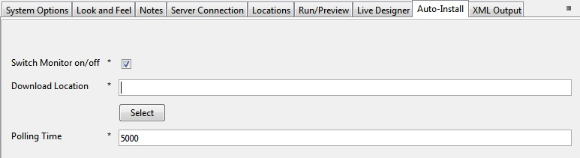

**Overview**

The **Google Calendar** widget allows a user to add an event to his Google Calendar. If the user it’s already logged in to his Google account he will not be prompted to login otherwise a pop-up will appear that prompt’s the user to login.

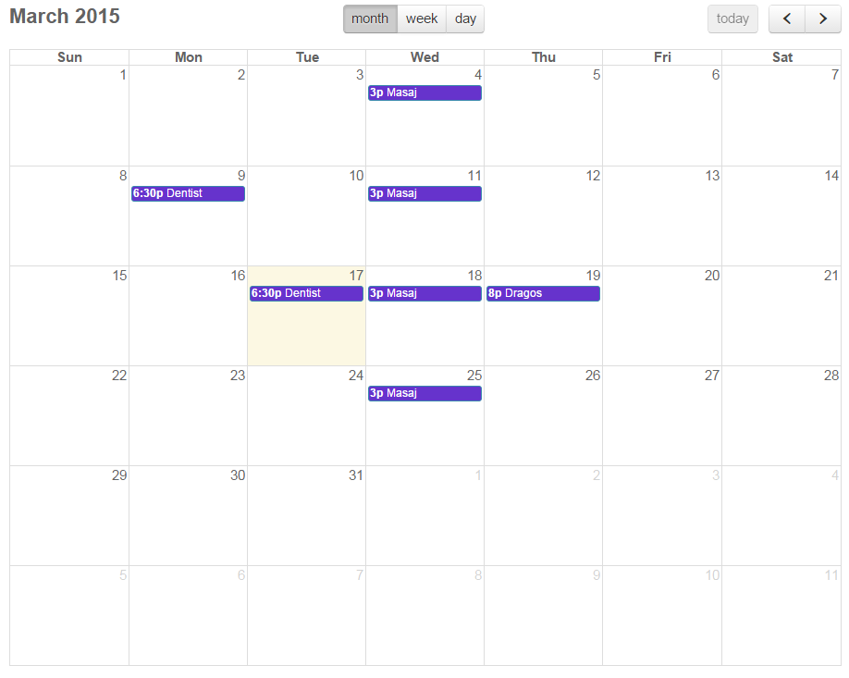

**Requirements**

For the widget to work you must have a **Client ID**. To find your project's client, do the following:

* Go to [**https://console.developers.google.com/project**](https://console.developers.google.com/project).
* Select a project, or create a new one.
* In the sidebar on the left, expand **APIs & auth**. Next, click **APIs**. In the list of APIs, make sure the status is **ON** for the Google Calendar API.
* In the sidebar on the left, select **Credentials**.
* If you haven't done so already, create your project's OAuth 2.0 credentials by clicking **Create new Client ID**, and providing the information needed to create the credentials.
* Look for the **Client ID** in the table associated with each of your credentials.

For the widget to fully work you must also enter the appropriate information into:

- **Authorized Javascript Origins**, for example:

http://localhost

http://10.140.2.105

http://localhost:8181

- **Authorized Redirect Uris**, for example:

http://localhost/oauth2callback

http://10.140.2.105/oauth2callback

http://localhost:8181/oauth2callback

**Setup**

1. Add a new **Google Calendar View** display item in the **Presentation Editor**;

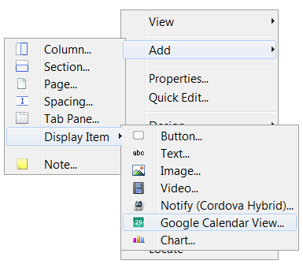

1. Fill the fields with the corresponding information in the **Widget Details** tab:

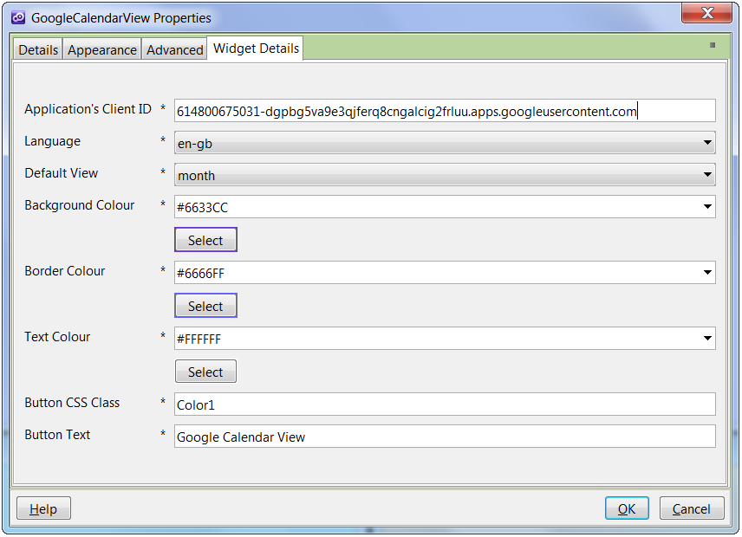

* **Application Client ID**: you can obtain this by following the requirements above;
* **Language**: choose which language you want the calendar to be in (default is **en-gb**);
* **Default View**: select the default view in which the calendar will render for the first time (default is **month**);
* **Background Colour**: select the color for the event’s background;
* **Border Colour**: select the color for the event’s border colour;
* **Text Colour**: select the color for the event’s text colour;
* **Button CSS Class**: enter the css class you want to use to style the **Google’s Calendar View** button;
* **Button Text**: enter the name of **Google’s Calendar View** button.